Lab Report No 1

Discrete Fourier Transform

Digital Image Processing



Submitted By:
[Huzaifa Shahbaz]
[21-CE-009]
[Aqsa Shah]
[21-CE-039]

Submitted to:
Engr. Hareem Khan
Dated:
27thSep,2024

Department of Computer Engineering,
HITEC University, Taxila
Lab Example No 1:

Solution:
Brief description (3-5 lines)
In this example we implement and run the code of Assigning single value to multiple variables in python.
The code
X = y = z = 50
print X
print y
print z
The results (Screenshot)
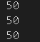
Lab Example No 2:

Solution:
Brief description (3-5 lines)
In this example we implement and run the code of Assigning multiple values to multiple variables in python.
The code
a,b,c=5,10,15
print a
print b
print c
The results (Screenshot)
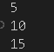
Lab Example No 3:

Solution:
Brief description (3-5 lines)
In this example we implement and run the code of Python Data Types in python.
The code
a=10
b="Hi python"
c=10.5
print(type(a))
print(type(b))
print(type(c))
The results (Screenshot)
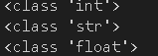
Lab Task No 2:

Solution:
Brief description (3-5 lines)
Write a Python code to solve the quadratic equation. (hint: import cmath library and use cmath.sqrt for this question)
The code
import cmath
def solve_quadratic(a, b, c):
discriminant = (b ** 2) - (4 * a * c)
sol1 = (-b + cmath.sqrt(discriminant)) / (2 * a)
sol2 = (-b - cmath.sqrt(discriminant)) / (2 * a)
return sol1, sol2
a = int(input("Enter coefficient a: "))
b = float(input("Enter coefficient b: "))
c = float(input("Enter coefficient c: "))
solution1, solution2 = solve_quadratic(a, b, c)
print(f"The solutions are {solution1} and {solution2}")
The results (Screenshot)
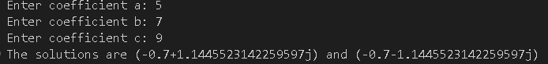
Lab Task No 3:

Solution:
Brief description (3-5 lines)
Write a Python code that implements basic calculator functioning (+, -, *, /) for user provided data of below mentioned data types.
a. int
b. float
The code
def add(x, y):
return x + y
def subtract(x, y):
return x - y
def multiply(x, y):
return x * y
def divide(x, y):
if y == 0:
return "Error! Division by zero."
return x / y
def calculator():
try:
num1 = float(input("Enter the first number (int or float): "))
num2 = float(input("Enter the second number (int or float): "))
print("Select operation:")
print("1. Add (+)")
print("2. Subtract (-)")
print("3. Multiply (*)")
print("4. Divide (/)")
choice = input("Enter choice (1/2/3/4): ")
if choice == '1':
print(f"{num1} + {num2} = {add(num1, num2)}")
elif choice == '2':
print(f"{num1} - {num2} = {subtract(num1, num2)}")
elif choice == '3':
print(f"{num1} * {num2} = {multiply(num1, num2)}")
elif choice == '4':
print(f"{num1} / {num2} = {divide(num1, num2)}")
else:
print("Invalid input! Please choose a valid operation.")
except ValueError:
print("Invalid input! Please enter a number.")
calculator()
The results (Screenshot)
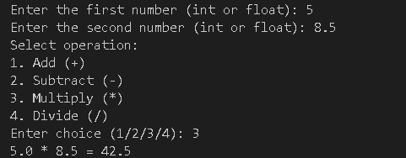
Conclusion
In the conclusion one of the most simple and readable language among high level programming languages Python is used in a great deal. These basic concepts are variables, data types, control structures (loops and branches), functions, and error handling. Python is multi-paradigm, it allows you to write code in many ways from procedural to object-oriented to functional programming. Python is great language for both newbie and experienced developers with its wide libraries and huge community. Learning this beginner material paves the way for higher-level subject matter and uses.

